UID LAB EXPERIMENT 4a
RAGHURAM K

Flowchart Documentation For Food Ordering App

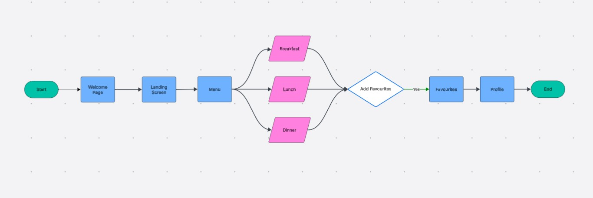

1. Overview
This document explains the process flow represented in the Lucidchart diagram. The flow illustrates a user journey through an application, starting from entry and proceeding through menu selection, category navigation, decision-making, and profile access before termination.

2. Flow Summary
The process follows a linear progression with a branching section for category selection and a decision node for adding items to favourites.
High-level sequence:
Start → Welcome Page → Landing Screen → Menu → (Breakfast / Lunch /
Dinner) → Add Favourites नणय → Favourites → Profile → End

3. Step-by-Step Explanation

3.1 Start
- Entry point of the system.
- Represents the initiation of the user session.

3.2 Welcome Page
- First screen displayed to the user.
- Acts as an introduction or entry interface.
- Typically includes branding or initial navigation option.

3.3 Landing Screen
- Main entry interface after the welcome page.
- Provides access to core features of the application.
- Serves as a transition point to the menu.

3.4 Menu
- Central navigation hub.
- Presents available categories for selection.
- Acts as a branching node leading to multiple options.

3.5 Category Selection (Breakfast / Lunch / Dinner)
- The flow splits into three parallel paths:
○ Breakfast
○ Lunch
○ Dinner
- Each path represents a category of items the user can explore.
- These are functionally equivalent paths differentiated only by category context.
- After interaction within a category, all paths converge back to a single decision point.

3.6 Decision Node: Add Favourites
- Represented by a diamond shape.
- Evaluates whether the user chooses to add selected items to favourites.
Possible outcomes:
- Yes → Proceed to Favourites
- No → (Implicitly ends or bypasses favourites; not explicitly shown in the diagram)

3.7 Favourites
- Displays items selected by the user.
- Acts as a collection or saved state of preferred items.
- Accessible only when the decision condition is satisfied.

3.8 Profile
- Represents user-specific information or account section.
- Allows access to personal data or settings.
- Positioned after favourites, indicating continued navigation.

3.9 End
- Terminal point of the flow.
- Indicates completion of the user journey.

4. Flow Characteristics
- Linear progression from start to menu
- Parallel branching for category selection
- Converging paths into a single decision node ● Conditional navigation based on user choice
- Single endpoint indicating completion

5. Logical Interpretation
- User enters the system and navigates through initial screens.
- User accesses the menu and selects a category.
- System allows browsing within the selected category.
- User decides whether to save items to favourites.
- If accepted, favourites are displayed.
- User proceeds to profile section.
- Flow terminates.

6. Conclusion
The flowchart clearly represents a structured user journey with defined navigation steps, category-based branching, and a decision-driven transition. It ensures clarity in user movement across the system while maintaining a simple and understandable process structure.

